Dear Stakeholder,
as you may know, MAFIN S.r.l. in compliance with the provisions of the law and with a view to guaranteeing correctness and transparency in the conduct of its business, it has set up a "Whistleblowing" computer system, available to anyone who wants to report situations relevant to the purposes of the law or internal regulations.
With the present document, we want to give you the instructions to follow to submit the report. The video tutorial will be sent to you with the login credentials in the first communication and it is also available at the following link: https://www.opendotcom.it/whistleblowing/video/spot-whistleblowing/17617.

CHARACTERISTICS OF THE REPORT
The report must refer solely to breaches of the law or of internal procedures and regulations, including the Code of Ethics, therefore, reports concerning complaints, personal requests or, more generally, irrelevant circumstances may not be taken into consideration.
The reports must be made in good faith, detailed and based on precise and concordant factual elements, also in order not to waste the effectiveness of the tool made available to you. Anyone who willfully or grossly negligent makes reports which subsequently turn out to be unfounded may be subject to disciplinary sanctions.

MANAGEMENT OF THE REPORTS
In order to protect as much as possible the "whistleblower" and the "signaled person", security measures have been adopted: confidentiality of the whistleblower identity and also of the content of the report are guaranteed through secure protocols and cryptographic tools that protect personal data and information provided. The identity of the whistleblower is never disclosed without his consent, with the exception of the cases provided for by current legislation. The competent body for the management of reports is the Reporting Manager.
In addition to the information provided, we invite you to read the Whistleblowing Procedure issued by the Company.

HOW TO SUBMIT A REPORT
- Access the link: https://mafin.segnalazioni.eu

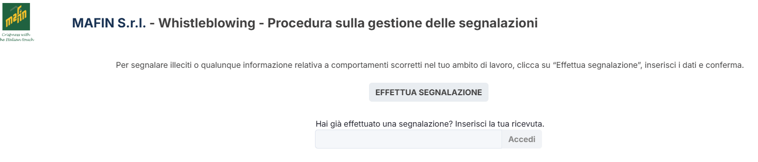

- Proceed by clicking the " Start Reporting Process" button.

- Having read the Privacy information, the whistleblower will proceed by filling in the form. The fields marked with the symbol * are mandatory. Some fields are open and must have a maximum number of characters.

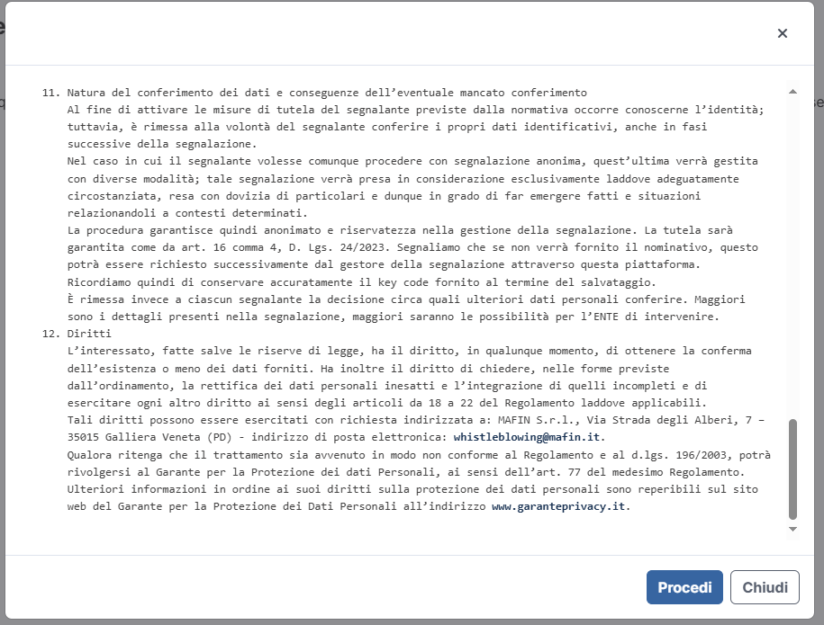
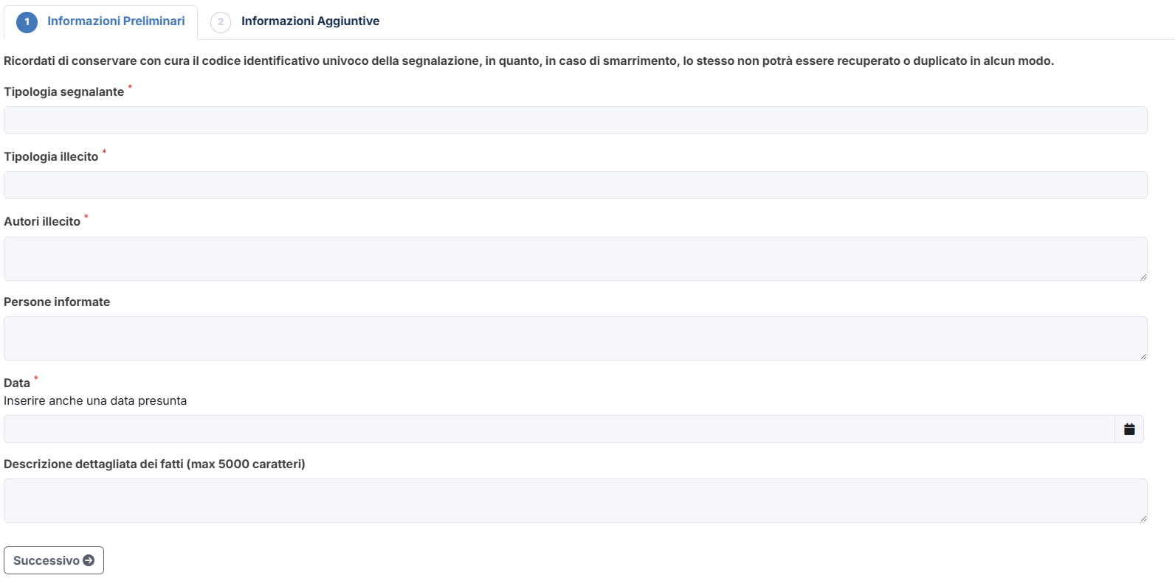
- It will be possible to proceed with the report.
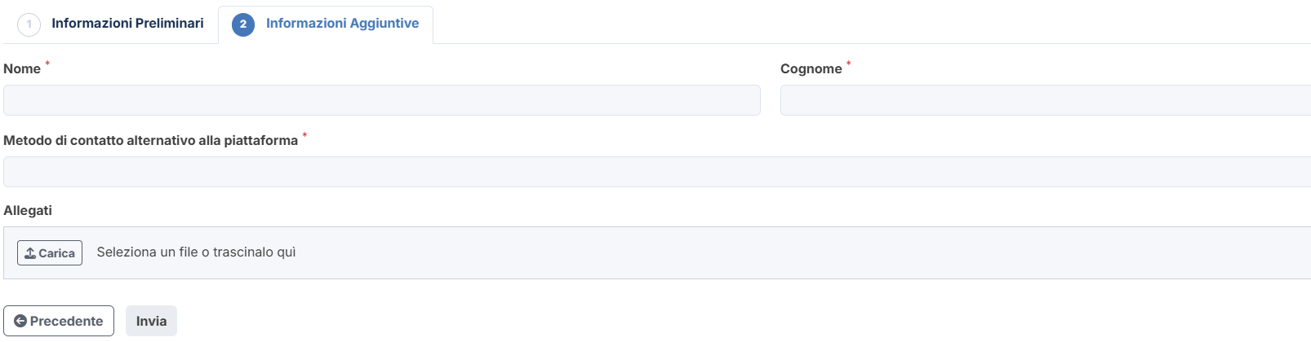

For any further questions or clarifications, please do not hesitate to contact your company manager.

Yours sincerely.
MAFIN S.r.l.

